Supplementary Materials:

# Benchmarks:

We first benchmark FLAC models against numerical thin plate models that assume restricted lava infill.

We then show the convergence of FLAC models as resolution increases.

# Elastic plate benchmark against numerical thin plate models and FLAC model convergence:

Model setup:

figures/Model-Setup-Elastic.pdf

Figure 1. Elastic layer benchmark with restricted lava infill. Model domain is 6 km thick and 100 km wide. Supported by winkler foundation of density 3000 kg/. The left boundary can freely move and the right boundary is fixed. The layer is elastic with density of 2800 kg/. The dike has a density of 3000 kg/ and provide a downward load at the rift axis.

|  |  |  |
| --- | --- | --- |
| Parameter names | Value | Unit |
| Model Width | 100 | km |
| Model Thickness | 6 | km |
| Dike height | 6 | km |
| Dike width | 1 | km |
| Lamé constant ( | 30 | GPa |
| Lamé constant () | 30 | GPa |
| Crustal density | 2800 | kg/ |
| Dike density | 3000 | kg/ |
| Lava infill density | 2800 | kg/ |
| Substrate density | 3000 | kg/ |
| # particles for SDR tracer | 600 | N/A |
| Gravitational acceleration (g) | 10 | m/ |

Table 1. FLAC model parameters for elastic plate.

|  |  |  |
| --- | --- | --- |
| Parameter names | Value | Unit |
| Model Width | 200 | km |
| Number of node points | 2001 | N/A |
| Height of dike | 6 | km |
| Te | 6 | km |
| Gravitational acceleration (g) | 10 | m/ |
| Young’s modulus | 75 | GPa |
| # iteration | 10 | N/A |
| Crustal density | 2800 | kg/ |
| Dike density | 3000 | kg/ |
| Lava infill density | 2800 | kg/ |
| Substrate density | 3000 | kg/ |

Table 2. Numerical thin plate model parameters.

For benchmarking against numerical thin plate model, we have model setup shown as figure 1. We let the model run till steady state and use the SDR tracer to quantitatively compared with semi-analytic results from numerical thin plate models.

For models results, take grid size of 1 km as an example:

figures/Results-1km.pdf

Figure 2. The phase and extensional stress at 100 kyrs of model time. Positive stress means extensional.

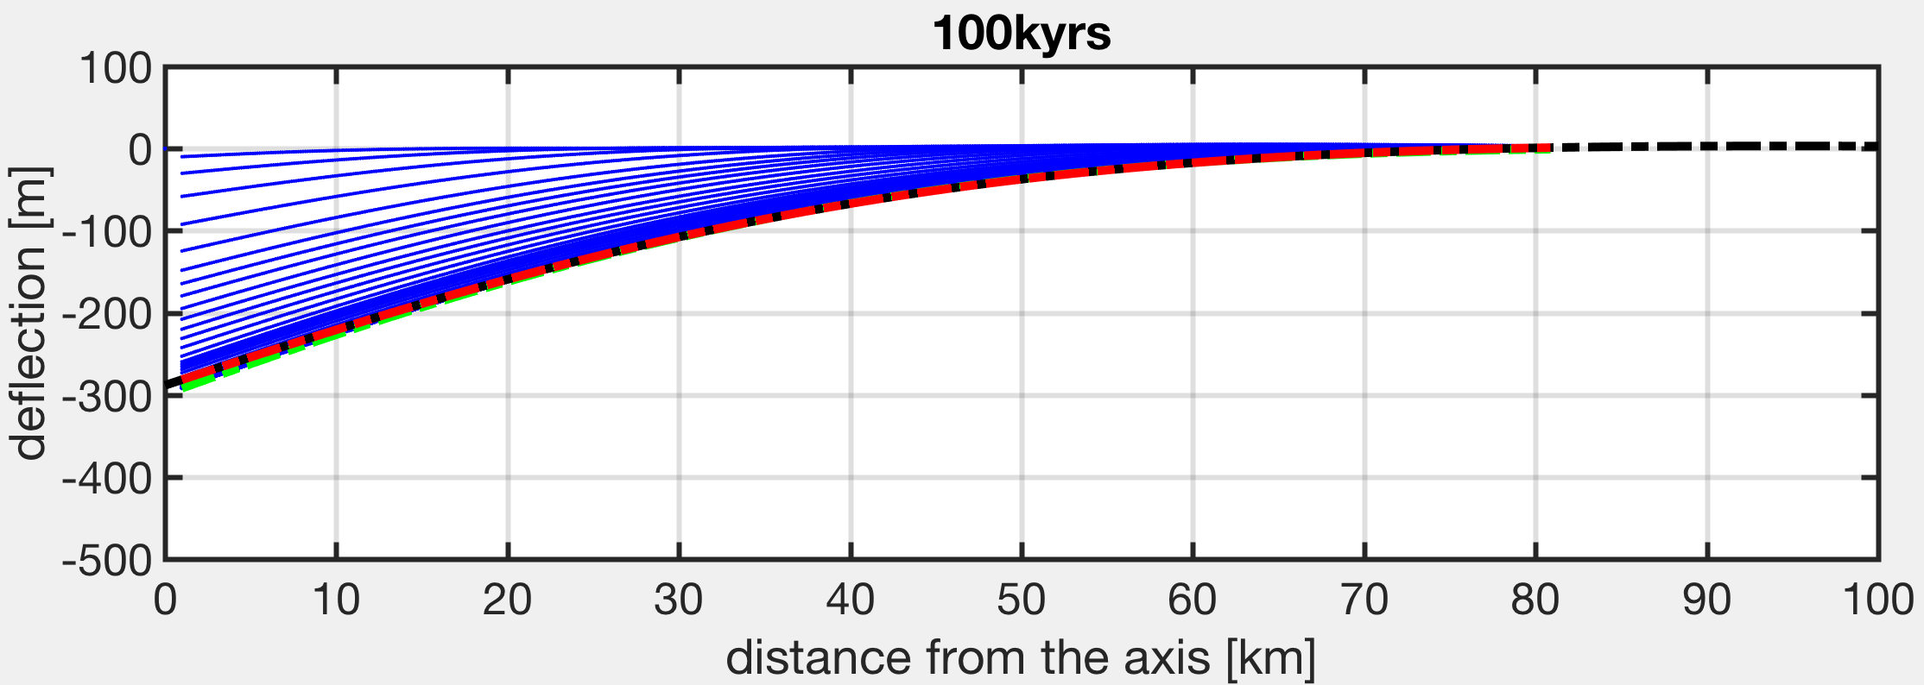

Figure 3. The locations of the SDR tracers are plotted on top of the numerical thin plate solution. The blue lines are SDR tracers with different model times. The green line is the final steady state at 100 kyrs. The red line is the result from numerical thin plate solution.

For grid size of 1 km, the average difference between the numerical thin plate solution and the FLAC model result is 1.99 meters over a maximum deflection at the axis of ~300 meters. This gives an error of less than 1% using the numerical thin plate model result as a reference. The thick plate FLAC model result shows slightly higher deflection at the axis, this could be due to the finite thickness compaction in vertical direction which can lead to extra vertical deflection compared to the thin plate solution. This extra 1% deflection is also consistent with previous study (e.g. [*Comer*, 1983]).

In addition, with the same model setup, we further test with other grid sizes showing in Figure 4:

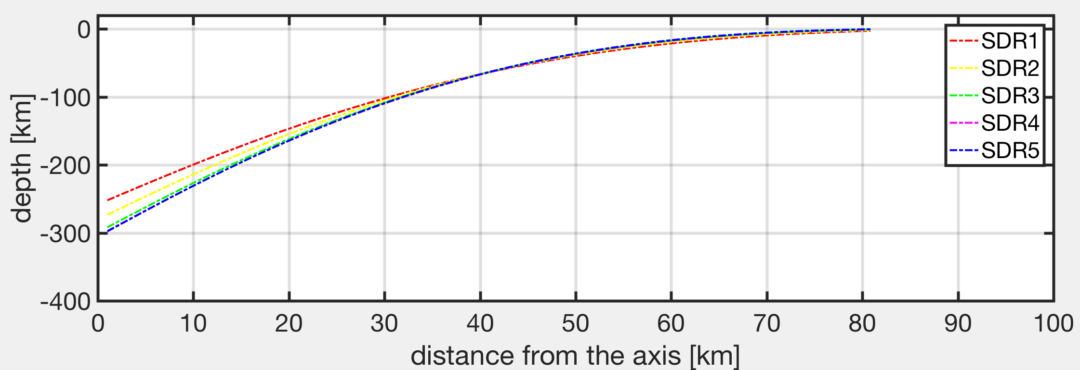

Figure 4. Overlapping model results with grid sizes of 3 km, 2 km, 1 km, 0.5 km, 0.25 km corresponding to SDR1, SDR2, SDR3, SDR4 and SDR5.

The difference between SDR5 (grid size of 0.25 km) and numerical thin plate result actually increases from 1.99 m of SDR3 to 3.27 m. However, when using the results from the highest resolution model (SDR5) as a reference, the model results indicate less than 2 meters of error of convergence when the model grid size decreases below 1 km, shown in Figure 5:

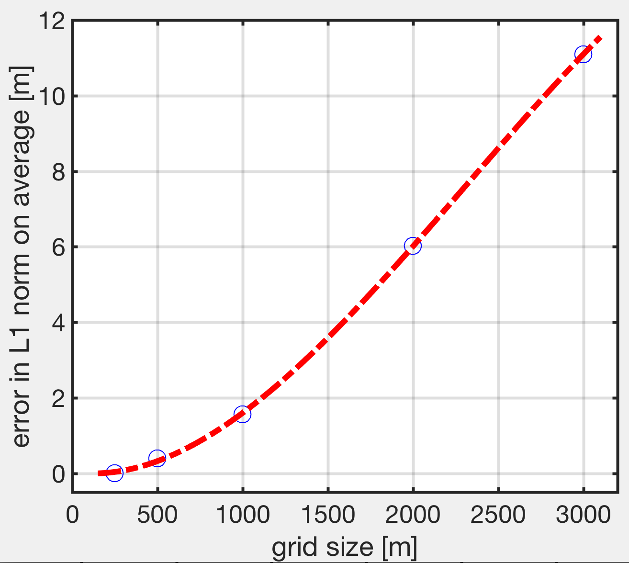

Figure 5. The average error as a function of grid sizes using results from the model with grid size of 0.25 km as the reference.

# Elastic-Plastic plate convergence:

Following same model setup to the Elastic plate model except for changing material property from elastic to elastic plastic, we compare the Elastic-plastic and numerical thin plate results to show the effect of plasticity on thick plate flexure. In addition, we also show the convergence of FLAC models with increasing grid resolutions. The model parameters remained the same for the numerical thin plate models but changes for the FLAC models are indicated boldly in Table 3:

|  |  |  |
| --- | --- | --- |
| Parameter names | Value | Unit |
| Model Width | 100 | km |
| Model Thickness | 6 | km |
| Dike height | 6 | km |
| Dike width | **4** | **km** |
| Lamé constant ( | 30 | GPa |
| Lamé constant () | 30 | GPa |
| Crustal density | 2800 | kg/ |
| Dike density | 3000 | kg/ |
| Lava infill density | 2800 | kg/ |
| Substrate density | 3000 | kg/ |
| # particles for SDR tracer | 600 | N/A |
| Gravitational acceleration (g) | 10 | m/ |
| Cohesion_i | **20** | **MPa** |
| Cohesion_e | **2** | **MPa** |
| Critical offset | **100** | **m** |
| Friction angle | **30** |  |
| Healing time | **1e+13** | **s** |

Table 3. FLAC model parameters for Elastic-plastic case.

Compared to the numerical thin plate models, the results show a shorter flexural wavelength due to the bending induced plastic failure near the surface of the plate taking grid size of 0.5 km as an example (Figure 6, 7):

figures/Results-EP-1km.pdf

Figure 6. Phase, density, extensional stress and plastic strain for the model at 100 kyrs with Elastic-plastic thick plate.

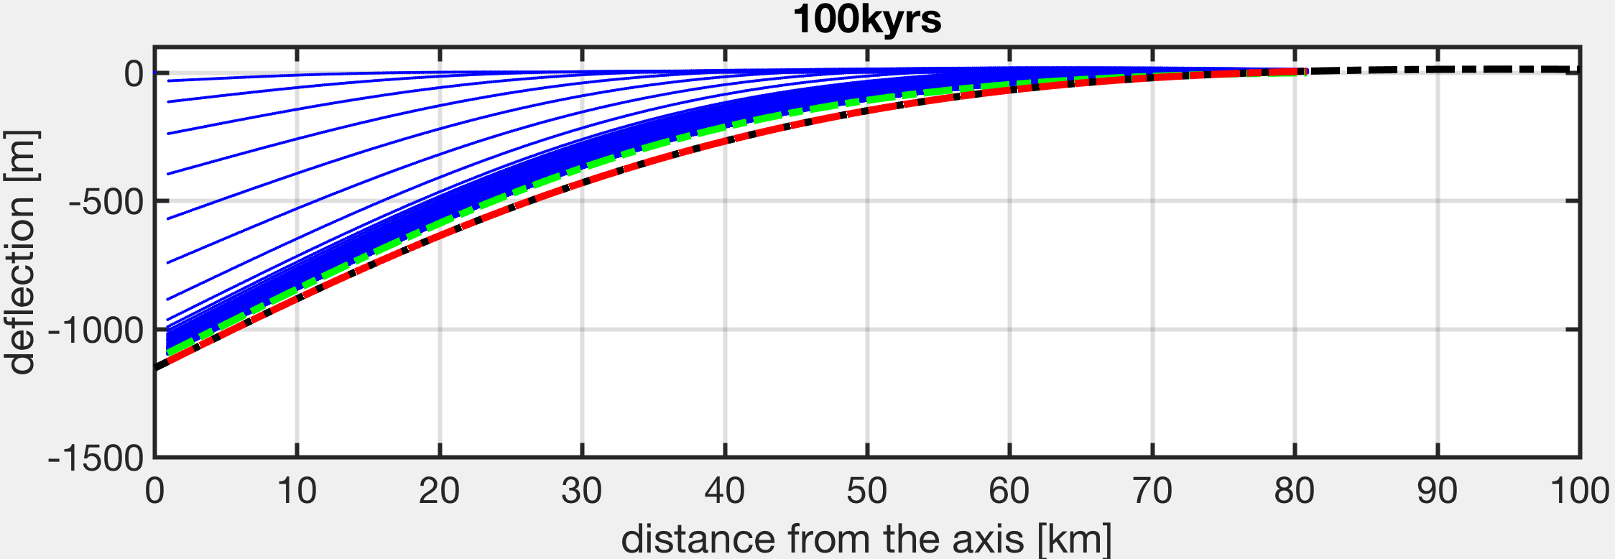

Figure 7. The locations of the SDR tracers are plotted on top of the numerical thin plate solution. The blue lines are SDR tracers with different model times. The green line is the final steady state at 100 kyrs. The red line is the result from numerical thin plate solution.

We further run the Elastic-plastic models with different grid size to test how well the FLAC models converges and to which grid size does the model converge. As shown in Figure 8 and 9, the models converge with decreasing grid size. Similar to that of elastic case, the relative error to the maximum deflection at the axis decreases within 1% when grid size decrease below 1 km.

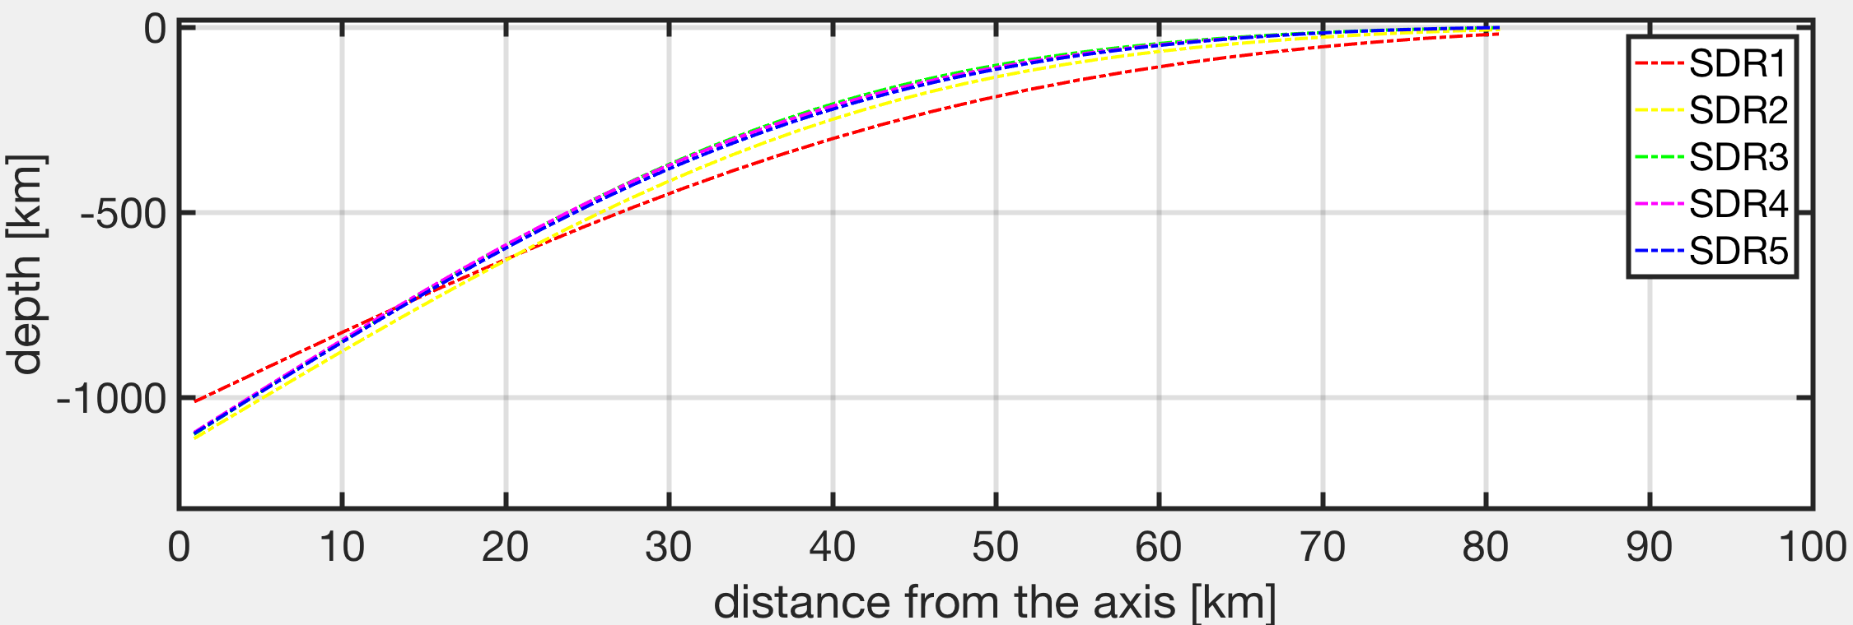

Figure 8. For Elastic-plastic models, overlapping model results with grid sizes of 3 km, 2 km, 1 km, 0.5 km, 0.25 km corresponding to SDR1, SDR2, SDR3, SDR4 and SDR5.

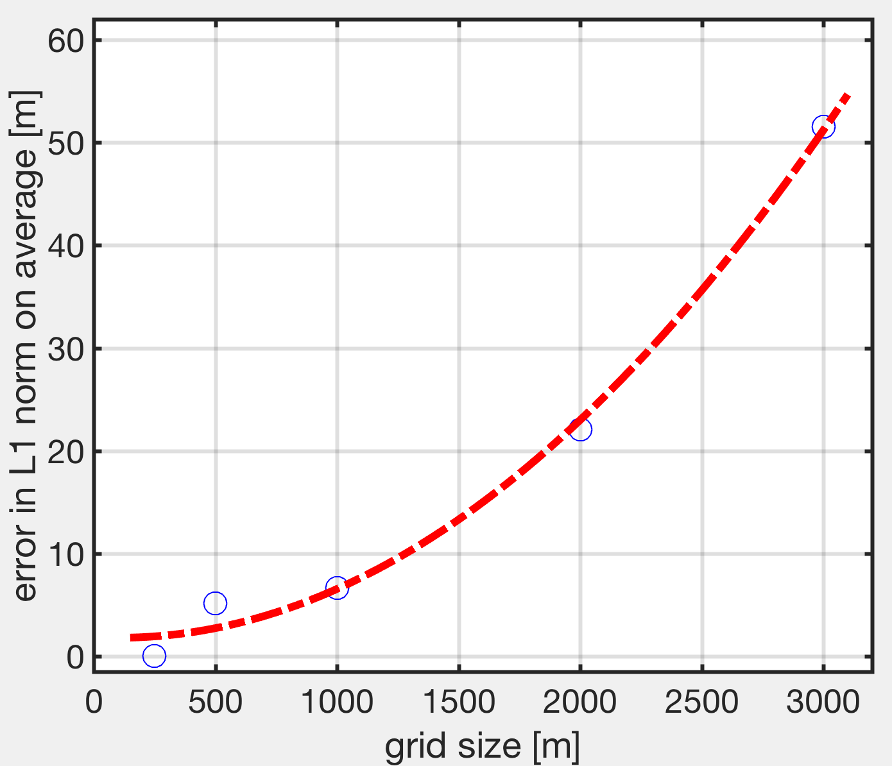

Figure 9. For Elastic-plastic models, the average error as a function of grid sizes using results from the model with grid size of 0.25 km as the reference.

References:

Comer, R. P. (1983), Thick plate flexure, *Geophys. J. Int.*, *72*(1), 101–113, doi:10.1111/j.1365-246X.1983.tb02807.x.